**"Big Data Analytics for Predictive Maintenance in Industrial Systems"**

**Abstract :** Big Data Analytics-enabled predictive maintenance has completely transformed industrial systems in a number of different industries. This literature review explores the evolving field of predictive maintenance and explains its critical role in reducing costly failures and improving operations. Using machine learning models, sharing real-world examples, and gathering, storing, and analyzing data are just a few of the important topics covered in the review. Along with highlighting the difficulties encountered, it also discusses recent developments and exciting possibilities.

This review attempts to provide a full knowledge of the interrelationship between Big Data Analytics and predictive maintenance by thoroughly reviewing research and industrial practices. Its ultimate goal is to assist in making informed judgments and successfully apply these strategies in industrial settings.

**1.Introduction :**

Predictive maintenance is changing how organizations maintain their investments in the modern industrial environment. This literature review investigates the combination of predictive maintenance and big data analytics in industrial systems. In order to prevent equipment breakdowns and reduce costs, predictive maintenance analyzes data from sensors and IoT devices.

this review has two important goals. first It starts by exploring the fundamental components of predictive maintenance: data gathering, storage, processing, and machine learning. Second, it gives a summary of the research that has already been done in this area. This review provides leaders, researchers, and professionals with an in-depth understanding of Big Data Analytics in predictive maintenance by combining current knowledge and analyzing trends and challenges.

Throughout this research, we will look at real-world case studies, highlight challenges in implementation, and deal with ethical issues related to the use of data. We'll also talk about new developments that are ready to change predictive maintenance, such as the integration of AI.

**2. Data Collection and sensors :**

With the development of IoT (Internet of Things) technology and the popularity of sensors, industrial systems have seen an incredible change. These systems now produce huge amounts of data, which are necessary for work at predictive maintenance. Understanding the predictive maintenance environment requires an understanding of how data is gathered and used.

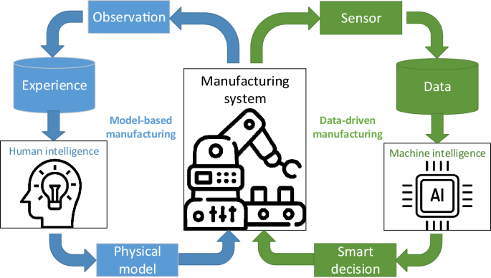

**types of Sensors:**

Industries that use predictive maintenance strategically use a variety of sensor categories. These sensors can measure a wide range of variables, including humidity, vibration, temperature, and pressure. Each sort of sensor offers vital information about the condition and functionality of the machinery.

* **IoT Devices:**

IoT devices are frequently the core of data collecting in predictive maintenance. These gadgets link sensors to the network, allowing for real-time data processing and transfer. Data collecting has been transformed by IoT since it is now more practical and affordable.

* **Data Velocity and Volume:**

Industrial systems produce continuous streams of data, and these data streams are identified by their great volume and velocity. Scalable solutions for data processing and storage are required because of the frequently excessive amount of data provided by sensors.

* **Data Variety :**

The information collected by industrial systems is very complex. It consists of both structured (like sensor readings) and unstructured (like maintenance logs, photos) data. In predictive maintenance, managing the variety of information is essential since insights frequently result from a combination of many data types.

* **Data Reliability:**

Data reliability and accuracy are important. Inaccurate or inconsistent data can lead to wrong predictions. Processes for validating and cleaning data are important in ensuring the accuracy of the data used in predictive maintenance.

* **Sensor Position:**

Sensors must be carefully placed on important machinery. Knowledge of the field and knowledge of the machinery failure modes are required to choose the best places for sensors.

* **Remote observation:**

Remote sensor monitoring has become common because of developments in communication technologies. This makes it possible for businesses to keep track of and analyze data from resource transfers throughout the world.

Predictive maintenance is determined on the basis of data collection. The following sections of this review will go into detail on how machine learning models and Big Data Analytics approaches are used to store, process, and turn this data into useful insights. To demonstrate the effectiveness of predictive maintenance solutions, we will look at actual case studies and further discuss these aspects in the sections that follow

**3. Data Storage and Processing :**

The success of predictive maintenance heavily relies on effective data storage and processing mechanisms. In this section, we'll explore the technologies and strategies employed to manage and analyze the vast volumes of data generated by sensors in industrial systems.

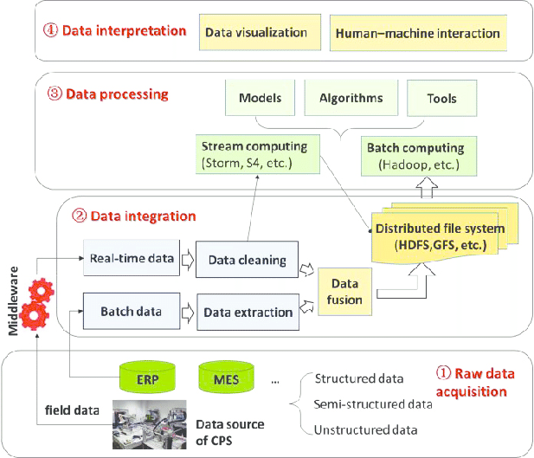

1. **Data Storage Solutions**

* 1. **Distributed Storage :**

The distribution of industrial data between different sensors and IoT devices is common. Data storage may be effective and scalable because of distributed storage systems like Hadoop Distributed File System (HDFS) and cloud-based storage platforms.

**b.Databases of time series:**

Time-series databases are well-suited for storing sensor data, as they are optimized for handling data points with timestamps. InfluxDB, OpenTSDB, and TimescaleDB are examples of databases designed for time-series data.

**c. Data Lakes:**

Data lakes have been used by businesses as a way to store various data of various types in their unprocessed state. Data exploration is made flexible by data lakes, which are frequently constructed on systems like Apache Lake and AWS S3.

1. **Data Processing Frameworks:**
   1. **Apache Spark:** Apache Spark is a versatile framework for distributed data processing. Its ability to handle batch and real-time processing makes it a popular choice for predictive maintenance tasks.
   2. **Stream Processing:** For real-time analysis of sensor data, stream processing frameworks like Apache Kafka and Apache Flink are instrumental. They enable the processing of data as it's generated, allowing for timely insights and immediate actions.
   3. **Data Preprocessing:** Data preprocessing steps, such as data cleaning, feature engineering, and outlier detection, are vital to ensure the quality of data used in predictive maintenance models.
2. **Machine Learning Integration:**
   1. **Feature Extraction:** Machine learning models for predictive maintenance often require feature extraction from sensor data. Feature engineering techniques play a crucial role in transforming raw data into meaningful features for modeling.
   2. **Model Training**: Machine learning algorithms, such as regression, classification, and time series forecasting models, are trained on historical sensor data to make predictions about equipment failures.
3. **Scalability and Performance:**
   1. **Parallelization:** To cope with the large volumes of data, predictive maintenance solutions are often designed to run in parallel across multiple computing nodes.
   2. **Real-Time Processing:** In some cases, real-time processing is essential, particularly when immediate action is needed to prevent equipment failure. Stream processing technologies excel in such scenarios.

Effective data storage and processing infrastructure creates the groundwork for timely and accurate predictions in predictive maintenance. The machine learning models and algorithms used to derive insights from this data and guide proactive maintenance decisions will be covered in more detail in the following section.

**5. Machine Learning Models:**

Machine learning is vital for predictive maintenance because it allows businesses to use huge amounts of sensor data for precise machinery condition evaluations and failure prediction. The various kinds of machine learning models used in predictive maintenance and their applications will be discussed in this section.

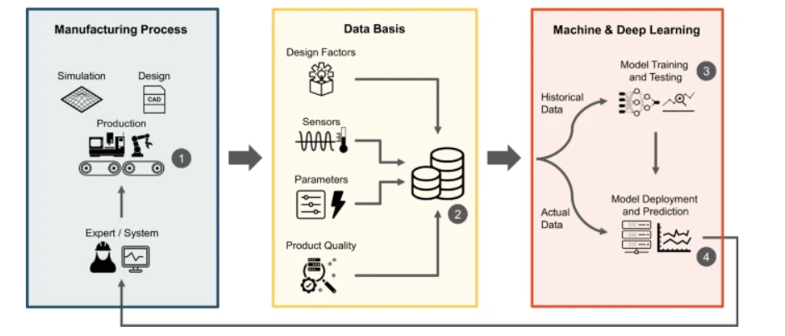

1. **Regression Models:**

**a. Linear Regression:**

Linear regression is often employed to predict equipment degradation over time. It's used to establish relationships between sensor data and the remaining useful life (RUL) of machinery.

**b. Logistic Regression:**

Logistic regression is utilized for binary classification tasks, such as determining whether a component will fail within a specified time frame.

1. **Classification Models:**

**a. Random Forest:** Random Forest is an ensemble learning technique known for its robustness and ability to handle high-dimensional data. It's used for classification tasks, including fault detection and asset failure prediction.

**b. Support Vector Machines (SVM):** SVM is employed in scenarios where clear class separation is required. It's used to classify equipment into different health states.

1. **Time Series Models:**

**a. ARIMA (AutoRegressive Integrated Moving Average):** ARIMA models are well-suited for time series data. They are used to forecast future sensor readings and detect anomalies.

**b. LSTM (Long Short-Term Memory):** LSTM is a type of recurrent neural network (RNN) capable of modeling long-range dependencies in time series data. It's effective in predicting equipment failures based on historical sensor readings.

1. **Deep Learning Models:**

**a. Convolutional Neural Networks (CNNs):** CNNs are employed when sensor data includes images or spatial information. They are used for feature extraction and fault detection in visual data.

**b. Recurrent Neural Networks (RNNs):** RNNs, including LSTM, are used for sequential data analysis. They excel at capturing temporal dependencies in sensor readings.

1. **Ensemble Learning:**

**a. XGBoost and Gradient Boosting:** Ensemble methods like XGBoost and gradient boosting are popular for combining the predictive power of multiple models. They enhance the accuracy of failure predictions.

Anomaly Detection Models:

**b. Isolation Forests:** Isolation forests are used to identify anomalies in sensor data, indicating potential equipment failures or abnormalities.

**C. One-Class SVM:** One-Class SVM is suitable for situations where normal data instances significantly outnumber anomalies. It's used to identify outliers in sensor data.

Machine learning is vital for predictive maintenance because it allows businesses to use huge amounts of sensor data for precise machinery condition evaluations and failure prediction. The various kinds of machine learning models used in predictive maintenance and their applications will be discussed in this section.

Machine learning models are trained on historical sensor data, incorporating features that describeA equipment behavior, environmental conditions, and operational parameters. These models are then used to forecast the condition of the equipment and its remaining lifespan, enabling preventive maintenance measures.

These models are then used to forecast the condition of the equipment and its remaining lifespan, enabling preventive maintenance measures.

**6. Case Studies**

**1. Aviation Industry: Pratt & Whitney's Predictive Engine Maintenance**

In the aviation industry, The reliability of aircraft engines plays an important role. Leading aircraft manufacturer Pratt & Whitney has adopted predictive maintenance to improve engine performance and safety. Pratt & Whitney forecasts component wear and probable failures by analyzing sensor data, including temperature, pressure, and vibration readings. As a result of reducing unscheduled maintenance and lowering the probability of in-flight problems, this proactive strategy has produced significant cost

**2. Siemens' Smart Manufacturing Solution for Manufacturing Excellence**

Predictive maintenance has been applied across all of Siemens' manufacturing plants. Siemens is a world leader in industrial automation and digitalization. Siemens is able to predict equipment breakdowns and effectively schedule maintenance tasks by using data from sensors integrated into manufacturing equipment. This strategy has not only reduced interruptions but also improved productivity and product quality, resulting in efficient production procedures.

**3. The Energy Sector: Using Vestas to Reduce Wind Turbine Downtime**

Predictive maintenance is used by Vestas, a top manufacturer of wind turbines, to enhance wind turbine performance in the renewable energy market. In order to monitor parameters like wind speed, temperature, and mechanical stress, Vestas gathers data from sensors on its turbines. By analyzing this data, Vestas is able to predict future failures and plan maintenance before serious problems occur. Due to this, turbine availability and energy output have greatly increased while maintenance costs have decreased.

**7. Challenges and Limitations**

While predictive maintenance has many benefits, it is not without challenges and restrictions. Understanding these issues is crucial for organizations looking to implement predictive maintenance effectively.

**1. Data Quality and Availability:**

**Challenge:** The quality and availability of data can be inconsistent. Sensor data may contain noise, missing values, or inaccuracies, making it challenging to build reliable predictive models.

**Limitation:** Incomplete or inaccurate data can lead to unreliable predictions, potentially resulting in unnecessary maintenance or missed opportunities to prevent failures.

**2. High Initial Costs:**

**Challenge:** Implementing predictive maintenance infrastructure, including sensors, data storage, and analysis tools, can entail high initial costs.

**Limitation:** Smaller organizations or those with budget constraints may find it challenging to invest in the necessary technology and expertise.

**3. Scalability:**

**Challenge:** As organizations expand their operations, scaling predictive maintenance solutions to accommodate a growing number of assets and sensors becomes complex.

**Limitation:** The scalability of predictive maintenance systems may require significant adjustments and investments in infrastructure and resources.

**4. Expertise Gap:**

**Challenge:** Building and maintaining predictive maintenance models requires data science and machine learning expertise that some organizations may lack.

**Limitation:** A shortage of skilled personnel can hinder the successful implementation and ongoing management of predictive maintenance systems.

**5. Data Privacy and Security:**

**Challenge:** Collecting and storing sensitive data from industrial systems raises concerns about data privacy and security.

**Limitation:** Strict regulations and the risk of data breaches require organizations to invest in robust security measures and compliance efforts.

**6. Model compatibility:**

**Challenge:** Complex machine learning models may lack compatibility, making it challenging to explain predictions to stakeholders or identify the root causes of failures.

**Limitation:** A lack of transparency can hinder trust in predictive maintenance systems, especially in safety-critical industries

**8. Future trends**

The topic of predictive maintenance is one that is always changing due to technological and data analytics breakthroughs. The future of predictive maintenance is being shaped by these new trends and technologies:

**1. Artificial Intelligence and Machine Learning Advancements:**

* **Explainable AI:** Developments in explainable AI are improving the interpretability of complex predictive models, allowing organizations to trust and understand the reasoning behind predictions.
* **Deep Learning:** Deep learning techniques, such as convolutional neural networks (CNNs) and recurrent neural networks (RNNs), are being further optimized for predictive maintenance, enabling more accurate predictions from complex data.

**2.Predictive Analytics in Cloud Services:**

* **Cloud-Based Solutions:** Cloud platforms provide scalable and cost-effective solutions for predictive maintenance. Organizations can leverage cloud-based analytics services to analyze vast datasets.
* **Machine Learning as a Service (MLaaS):** MLaaS offerings simplify the deployment of machine learning models, making predictive maintenance accessible to a broader range of organizations.

**3. IoT and 5G Connectivity:**

* **Enhanced Sensor Networks:** The expansion of IoT and the deployment of 5G networks enable seamless connectivity and data transmission from a multitude of sensors, improving data collection and analysis.

**4.Augmented Reality (AR) and Virtual Reality (VR):**

* **Remote Maintenance and Training:** AR and VR technologies are used for remote maintenance support, allowing technicians to visualize equipment and receive guidance in real time.
* **Training Simulations:** AR and VR can also facilitate training simulations for maintenance personnel, reducing training costs and enhancing skills.

Predictive maintenance will become an even more valuable tool for improving operations, cutting costs, and assuring the long-term reliability of industrial assets as a result of these emerging trends and technology.

**9. Conclusion**

With the ability to predict and avoid equipment breakdowns, reduce downtime, and improve operations, predictive maintenance is at the top of industrial asset management. The different components of predictive maintenance have been explored in this literature review, including data collecting, machine learning models, real-world case studies, and difficulties.

The practical advantages of predictive maintenance across industries are underlined through case studies from Pratt & Whitney, Siemens, and Vestas. The road to successful adoption, however, is not without obstacles, including issues with data quality and privacy.

With improvements in artificial intelligence, edge computing, and environmental initiatives, the future of predictive maintenance is bright. Organizations have to find a balance between data-driven insights and ethical, privacy, and worker well-being issues in order to fully exploit its potential.

In conclusion, predictive maintenance is a strategic necessity for businesses looking to manage assets in advance, cut costs, and improve sustainability. Organizations can deal with the difficulties of predictive maintenance and take advantage of the opportunities that it presents by using the insights provided in this review.

**References :**

**1. Title**: Predictive Maintenance of Aircraft Engines Based on Data Mining and Prognostics

**Authors:** Lei Yu, Jingxian Wu, and Jie Zhao

**Published in:** 2011 IEEE International Conference on Prognostics and Health Management (PHM)

**2.Title:** Predictive Maintenance: A Data-Driven Approach

**Authors:** J. He, Y. Wang, and S. Yang

**Published in:** Procedia CIRP, Volume 38, 2015, Pages 89-94

**3,Title:** Predictive Maintenance in Industry 4.0 for Sustainable Manufacturing

**Authors:** Jiaqi Guan, Kai Wu, and Hongyu Wu

**Published in:** Procedia CIRP, Volume 84, 2019, Pages 467-472

**4.Title:** Predictive Maintenance for Wind Turbines: A Data-Mining Approach

**Authors:** Lyes Khoukhi and Tarek Bejaoui

**Published in:** Procedia Computer Science, Volume 83, 2016, Pages 407-414

**5.Title:** Predictive Maintenance in Condition-Based Maintenance: A Review

**Authors:** M.F. Kannangara, G. Macchiavello, and L. Ranasinghe

**Published in:** IEEE Access, Volume 9, 2021, Pages 20767-20789

**6.Title:** Predictive Maintenance and Machine Learning in Industry 4.0

**Authors:** Amit J. Patel and Dipesh H. Shah

**Published in:** 2018 International Conference on Information and Communication Technology Convergence (ICTC)